JAVA PROGRAMMING(CS23304)

NAME : NAVEENA R
REG NO : 2025503529
DEPT : COMPUTER TECHNOLOGY
BATCH : A

EXERCISE 6 – CLASSES AND OBJECTS
Aim
To study and implement the concept of classes and objects in Java by creating objects using constructors and methods, and to develop a Library Management System to calculate fines for different categories of library members based on overdue days.
Procedure
- Create a Library class with data members and methods.
- Define default and parameterized constructors.
- Accept the member ID, category and overdue days.
- Calculate the fine based on the member category and overdue days.
- Display the member details and calculated fine.
- Execute the program and verify the output.
Program
Write a Java program to implement a Library Fine Calculation System using classes and objects. The program should accept the member ID, member category (UG/PG/RS/Faculty), and number of overdue days, and calculate the library fine according to the respective category's fine rules. Display the member details and the calculated fine amount.
import java.util.Scanner;

class LibraryMember {
int memberId;
String memberName;
String category;
int delayDays;

LibraryMember() {
memberId = 0;
memberName = "unknown";
category = "UG";
delayDays = 0;
}

LibraryMember(int id, String name, String cat, int days) {
memberId = id;
memberName = name;
category = cat;
delayDays = days;
}

double calculateFine(String category, int days) {
double fine = 0;

if (category.equalsIgnoreCase("UG")) {
if (days <= 15)
fine = 0;
else if (days <= 25)
fine = (days - 15) * 5;
else if (days <= 40)
fine = (10 * 5) + (days - 25) * 10;
else
fine = (10 * 5) + (15 * 10) + (days - 40) * 15;
}

else if (category.equalsIgnoreCase("PG")) {
if (days <= 30)
fine = 0;
else if (days <= 60)
fine = (days - 30) * 10;
else
fine = (30 * 10) + (days - 60) * 15;
}

else if (category.equalsIgnoreCase("Research")) {
if (days <= 60)
fine = 0;
else if (days <= 90)
fine = (days - 60) * 10;
else
fine = (30 * 10) + (days - 90) * 15;
}

return fine;
}

void display() {
double fine = calculateFine(category, delayDays);

System.out.println("Member ID: " + memberId);
System.out.println("Member Name: " + memberName);
System.out.println("Category: " + category);
System.out.println("Delayed Days: " + delayDays);
System.out.println("Total Fine: " + fine);
}
}

public class LibraryManagementSystem {
public static void main(String[] args) {

Scanner sc = new Scanner(System.in);

System.out.println("Enter number of members:");
int n = sc.nextInt();

LibraryMember[] members = new LibraryMember[n];

for (int i = 0; i < n; i++) {

System.out.println("Enter details for member " + (i + 1));

System.out.print("Enter member ID: ");
int id = sc.nextInt();
sc.nextLine();

System.out.print("Enter member name: ");
String name = sc.nextLine();

System.out.print("Enter category (UG/PG/Research): ");
String category = sc.next();

System.out.print("Enter delayed days: ");
int days = sc.nextInt();

members[i] = new LibraryMember(id, name, category, days);
}

System.out.println("\n--- MEMBER DETAILS ---");

for (int i = 0; i < n; i++) {
members[i].display();
System.out.println();
}

sc.close();
}
}
Output
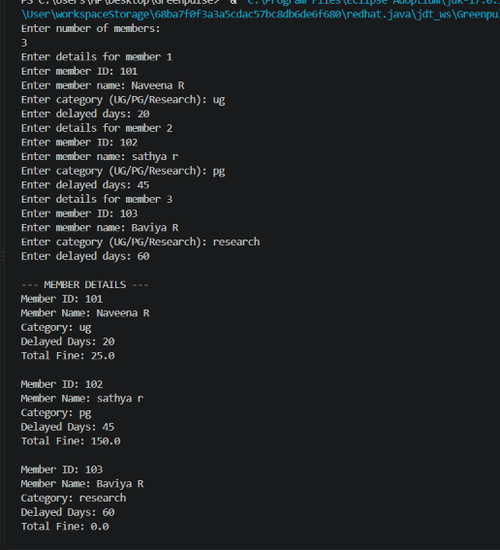

Result
The Java program demonstrating the concept of classes and objects was successfully implemented, and the library fine for different categories of members was calculated and displayed based on the overdue days.

EXERCISE 7 – INHERITANCE AND POLYMORPHISM
Aim
To write a Java program using inheritance, method overriding, and an array of objects to calculate the total marks and grade of full-time and part-time students for three courses.
Procedure
- Create a parent class Student with common data members and methods.
- Create child classes Fulltime and Parttime using inheritance.
- Create an array of Course objects to store the marks of three courses.
- Override the calculateMarks() method in the child classes to calculate the total marks.
- Use the common grade() method present in the parent class to calculate the grade.
- Execute the program and verify the result.
Program
Write a Java program to implement a Student Marks and Grade Calculation System using inheritance and polymorphism. The program should calculate the total marks and average for three courses for both Full-Time and Part-Time students using their respective assessment, semester examination, and continuous assessment weightages. Finally, display the student's total, average, and grade.
import java.util.*;
class Course{
String name;
float ass1, ass2, sem, ca;
}
class Student{
int roll;
String name;
float total;
Course c[] = new Course[3];
Student() {
for (int i = 0; i < 3; i++){
c[i] = new Course();
}
}
void getDetails(){
Scanner sc = new Scanner(System.in);
System.out.print("Enter Roll No: ");
roll = sc.nextInt();
sc.nextLine();
System.out.print("Enter Name: ");
name = sc.nextLine();
}
void calculateMarks() { }
void grade() {
float avg = total / 3;
System.out.println("\nTotal = " + total);
System.out.println("Average = " + avg);
if (avg >= 90)
System.out.println("Grade: O");
else if (avg >= 80)
System.out.println("Grade: A+");
else if (avg >= 70)
System.out.println("Grade: A");
else if (avg >= 60)
System.out.println("Grade: B+");
else if (avg >= 50)
System.out.println("Grade: B");
else
System.out.println("Grade: Fail");
}
}
class Fulltime extends Student{
void getMarks(){
Scanner sc = new Scanner(System.in);
for (int i = 0; i < 3; i++){
System.out.println("\nCourse " + (i + 1));
System.out.print("Course Name: ");
c[i].name = sc.nextLine();
System.out.print("Assessment: ");
c[i].ass1 = sc.nextFloat();
System.out.print("Semester: ");
c[i].sem = sc.nextFloat();
System.out.print("CA: ");
c[i].ca = sc.nextFloat();
sc.nextLine();
}
}
void calculateMarks(){
total = 0;
for (int i = 0; i < 3; i++) {
total += c[i].ass1 * 0.2f + c[i].sem * 0.4f+ c[i].ca * 0.4f;
}
}
class Parttime extends Student{
void getMarks() {
Scanner sc = new Scanner(System.in);
for (int i = 0; i < 3; i++) {
System.out.println("\nCourse " + (i + 1));
System.out.print("Course Name: ");
c[i].name = sc.nextLine();
System.out.print("Assessment 1: ");
c[i].ass1 = sc.nextFloat();
System.out.print("Assessment 2: ");
c[i].ass2 = sc.nextFloat();
System.out.print("Semester: ");
c[i].sem = sc.nextFloat();
System.out.print("CA: ");
c[i].ca = sc.nextFloat();
sc.nextLine();
}
}
void calculateMarks() {
total = 0;
for (int i = 0; i < 3; i++) {
total += c[i].ass1 * 0.2f+ c[i].ass2 * 0.2f+ c[i].sem * 0.4f + c[i].ca * 0.2f;
}
}
public class Grade{
public static void main(String args[]) {
Scanner sc = new Scanner(System.in);
Student s;
System.out.println("1. Full Time");
System.out.println("2. Part Time");
System.out.print("Enter Choice: ");
int ch = sc.nextInt();
if (ch == 1) {
Fulltime f = new Fulltime();
f.getDetails();
f.getMarks();
s = f;
}
else {
Parttime p = new Parttime();
p.getDetails();
p.getMarks();
s = p;
}
s.calculateMarks();
s.grade();
sc.close();
}
}
Output
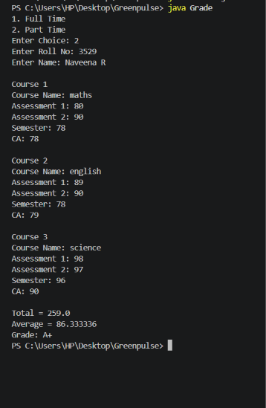

Result
The program was executed successfully. The concepts of inheritance and polymorphism were implemented to calculate the total marks and grade of full-time and part-time students for three courses.

EXERCISE 8 – OBJECT HANDLING
Aim
To write a Java programs to demonstrate object handling concepts such as object creation, object reference, copy constructor, object identity and object equality.
Procedure
- Create a Student class with rollno and name as data members.
- Define a parameterized constructor to initialize the student details.
- Create three different student objects.
- Display the hash code of each object using the hashCode() method.
- Compare the objects and observe their hash codes.
- Execute the program and verify the output.
Program 1 :
Write a Java program to create three Student objects, print the hash codes for each object, and determine whether the objects are the same or different.
class Student{
int rollno;
String name;
Student(int r, String n) {
rollno = r;
name = n;
}
}

public class HashCode{
public static void main(String args[]) {
Student s1 = new Student(101, "Arun");
Student s2 = new Student(102, "Bala");
Student s3 = new Student(103, "Charan");
System.out.println("Hash Code of Student 1: " + s1.hashCode());
System.out.println("Hash Code of Student 2: " + s2.hashCode());
System.out.println("Hash Code of Student 3: " + s3.hashCode());
}
}
Output
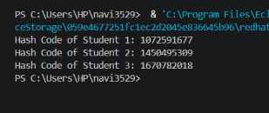

Program 2 :
Write a Java program to demonstrate object reference by assigning one object reference to another and comparing their hash codes.
class Student
{
int rollno;
String name;
Student(int r, String n) {
rollno = r;
name = n;
}
}
public class ObjectReference{
public static void main(String args[]{
Student s1 = new Student(101, "Arun");
Student s2 = new Student(102, "Bala");
System.out.println("Before assigning reference:");
System.out.println("Hash Code of s1: " + s1.hashCode());
System.out.println("Hash Code of s2: " + s2.hashCode());
s2 = s1;
System.out.println("After assigning reference:");
System.out.println("Hash Code of s1: " + s1.hashCode());
System.out.println("Hash Code of s2: " + s2.hashCode());
}
}
Output
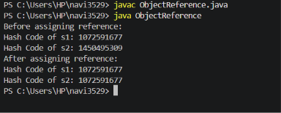

Program 3 :
To create a Java program using a copy constructor to create a copy of an object and compare the original and copied objects using the == operator.
class Student{
int rollno;
String name;
Student(int r, String n){
rollno = r;
name = n;
}
Student(Student s){
rollno = s.rollno;
name = s.name;
}
void display() {
System.out.println("Roll No: " + rollno);
System.out.println("Name: " + name);
}
}
public class CopyConstructorDemo{
public static void main(String args[]) {
Student s1 = new Student(101, "Arun");
Student s2 = new Student(s1);
System.out.println("Original Object:");
s1.display();
System.out.println("HashCode: " + s1.hashCode());
System.out.println();
System.out.println("Copied Object:");
s2.display();
System.out.println("HashCode: " + s2.hashCode());
System.out.println();
if (s1 == s2)
System.out.println("Both objects are same");
else
System.out.println("Both objects are different");
}
}
Output
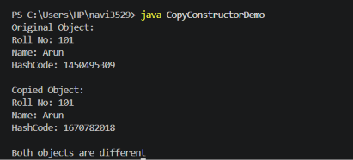
Program 4 :
Write a Java program to compare two objects using the == operator and the equals() method, and to understand object identity and object equality.
class Student{
int rollno;
String name;
Student(int r, String n) {
rollno = r;
name = n;
}
public boolean equals(Object obj){
Student s = (Student)obj;
return rollno == s.rollno && name.equals(s.name);
}
}

public class Compare{
public static void main(String args[]) {
Student s1 = new Student(101, "Arun");
Student s2 = new Student(101, "Arun");
if(s1 == s2)
System.out.println("Using == : Same objects");
else
System.out.println("Using == : Different objects");
if(s1.equals(s2))
System.out.println("Using equals: Same objects");
else
System.out.println("Using equals: Different objects");
}
}

Output
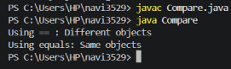
Result
The program was executed successfully. The hash codes of three different Student objects were displayed, demonstrating that each object has its own object identity.

EXERCISE 9 – USAGE OF STATIC, FINAL AND ABSTRACT CLASSES
Aim
To develop a Java program for a Vehicle Toll Collection System using an abstract class, final variable, final method, static variable, static method, and static block.
Procedure
- Create an abstract class Vehicle.
- Declare a final vehicle number and static vehicle count.
- Declare a static final basic toll fee.
- Create a static block to initialize the vehicle count.
- Create subclasses Car, Bus, and Truck.
- Override the abstract method calculateToll().
- Display the vehicle details, toll amount, and total number of vehicles processed.
Program
Write a Java program to implement a Vehicle Toll Collection System using static, final, and abstract classes. Create an abstract Vehicle class and derive Car, Bus, and Truck classes from it. Calculate the toll amount for each vehicle using a basic fee and an additional vehicle-specific fee. Display the vehicle number, toll amount, and total number of vehicles passed.
abstract class Vehicle{
final String vehicleNo;
static int vehicleCount;
static final int basicFee = 50;
static {
vehicleCount = 0;
System.out.println("Vehicle Toll Collection System");
}
Vehicle(String vehicleNo) {
this.vehicleNo = vehicleNo;
vehicleCount++;
}
abstract double calculateToll();
final void display() {
System.out.println("Vehicle Number: " + vehicleNo);
System.out.println("Toll Amount: " + calculateToll());
System.out.println();
}
static void displayCount() {
System.out.println("Total Vehicles Passed: " + vehicleCount);
}
}

class Bus extends Vehicle{
static final int Extra = 35;
Bus(String vehicleNo) {
super(vehicleNo);
}
double calculateToll() {
return basicFee + Extra;
}
}

class Car extends Vehicle{
static final int Extra = 15;
Car(String vehicleNo) {
super(vehicleNo);
}
double calculateToll() {
return basicFee + Extra;
}
}

class Truck extends Vehicle{
static final int Extra = 85;
Truck(String vehicleNo) {
super(vehicleNo);
}
double calculateToll() {
return basicFee + Extra;
}
}

public class Demo{
public static void main(String args[]) {
Car c = new Car("TN01AB1234");
Bus b = new Bus("TN02CD5678");
Truck t = new Truck("TN03EF9012");
c.display();
b.display();
t.display();
Vehicle.displayCount();
}
}
Output
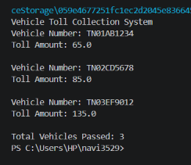
Result
The Java program was executed successfully. The Vehicle Toll Collection System demonstrated the use of abstract classes, abstract methods, static variables, static methods, static blocks, final variables, and final methods. The toll amount and total number of vehicles processed were displayed successfully.

EXERCISE 10 – PACKAGES AND INTERFACES
Aim
To develop Java applications using packages and interfaces to improve modularity, code reusability, maintainability, and secure access, and to demonstrate concepts such as package creation, user-defined packages, inter-package access, access specifiers, interfaces, and polymorphism.
Procedure:
- Create the required Java classes and interfaces according to the given problem statements.
- Define common operations using interfaces wherever required.
- Create user-defined packages and organize the related classes into appropriate packages.
- Use access specifiers such as public, private, and default wherever required.
- Import the required packages into the main program.
- Create objects and access the required methods from different packages.
- Accept the required input from the user.
- Perform the required insurance/hospital management operations.
- Compile and execute the Java programs.
- Verify the results with the expected output.

Program 1 :
Write a Java program to implement an Insurance Policy Management System using interfaces. Create interfaces for obtaining customer details, displaying policy information, calculating premium, and estimating the claim amount. Implement these interfaces using Health, Vehicle, and Life insurance classes. Allow the user to select an insurance type and display the customer details, premium, claim amount, interest, and final claim amount.
import java.util.*;
interface A{
void getdetails();
void display();
static void company() {
System.out.println("ABC Insurance Company");
}
}

interface B{
void premiumcal();
void estimation();
default void message() {
System.out.println("Policy operations completed.");
}
}

class Health implements A,B{
String name;
int age,year,p,premium;
double amount,interest,claim;
public void getdetails(){
Scanner s=new Scanner(System.in);
System.out.print("Enter name: ");
name=s.nextLine();
System.out.print("Enter age: ");
age=s.nextInt();
System.out.print("Enter policy period: ");
year=s.nextInt();
System.out.println("Package 1 : 499");
System.out.println("Package 2 : 899");
System.out.println("Package 3 : 1299");
System.out.print("Enter package: ");
p=s.nextInt();
}
public void premiumcal() {
if(p==1)
premium=2500+499;
else if(p==2)
premium=2600+899;
else
premium=2600+1299;
}
public void estimation() {
amount=premium*(1.2*year);
interest=amount*0.08;
claim=amount+interest;
}
public void display() {
System.out.println("Customer name: "+name);
System.out.println("Customer Age: "+age);
System.out.println("Policy Type: Health Insurance");
System.out.println("Policy period: "+year+" years");
System.out.println("Monthly premium: "+premium);
System.out.println("Claim Amount: "+amount);
System.out.println("8% Interest: "+interest);
System.out.println("Final claim amount: "+claim);
message();
}
}

class Vehicle implements A,B{
String name;
int age,year,p,premium;
double amount,interest,claim;
public void getdetails() {
Scanner s=new Scanner(System.in);
System.out.print("Enter name: ");
name=s.nextLine();
System.out.print("Enter age: ");
age=s.nextInt();
System.out.print("Enter policy period: ");
year=s.nextInt();
System.out.println("Package 1 : 599");
System.out.println("Package 2 : 999");
System.out.println("Package 3 : 1499");
System.out.print("Enter package: ");
p=s.nextInt();
}
public void premiumcal(){
if(p==1)
premium=2000+599;
else if(p==2)
premium=2000+999;
else
premium=2000+1499;
}
public void estimation() {
amount=premium*(1.2*year);
interest=amount*0.08;
claim=amount+interest;
}
public void display(){
System.out.println("Customer name: "+name);
System.out.println("Customer Age: "+age);
System.out.println("Policy Type: Vehicle Insurance");
System.out.println("Policy period: "+year+" years");
System.out.println("Monthly premium: "+premium);
System.out.println("Claim Amount: "+amount);
System.out.println("8% Interest: "+interest);
System.out.println("Final claim amount: "+claim);
message();
}
}

class Life implements A,B{
String name;
int age,year,p,premium;
double amount,interest,claim;
public void getdetails() {
Scanner s=new Scanner(System.in);
System.out.print("Enter name: ");
name=s.nextLine();
System.out.print("Enter age: ");
age=s.nextInt();
System.out.print("Enter policy period: ");
year=s.nextInt();
System.out.println("Package 1 : 699");
System.out.println("Package 2 : 1099");
System.out.println("Package 3 : 1599");
System.out.print("Enter package: ");
p=s.nextInt();
}
public void premiumcal(){
if(p==1)
premium=3000+699;
else if(p==2)
premium=3000+1099;
else
premium=3000+1599;
}
public void estimation() {
amount=premium*(1.2*year);
interest=amount*0.08;
claim=amount+interest;
}
public void display(){
System.out.println("Customer name: "+name);
System.out.println("Customer Age: "+age);
System.out.println("Policy Type: Life Insurance");
System.out.println("Policy period: "+year+" years");
System.out.println("Monthly premium: "+premium);
System.out.println("Claim Amount: "+amount);
System.out.println("8% Interest: "+interest);
System.out.println("Final claim amount: "+claim);
message();
}
}

public class Pack{
public static void main(String args[]) {
Scanner s=new Scanner(System.in);
A.company();
System.out.println("1. Health Insurance");
System.out.println("2. Vehicle Insurance");
System.out.println("3. Life Insurance");
System.out.print("Enter choice: ");
int choice=s.nextInt();
s.nextLine();
if(choice==1) {
Health h=new Health();
h.getdetails();
h.premiumcal();
h.estimation();
h.display();
}
else if(choice==2) {
Vehicle v=new Vehicle();
v.getdetails();
v.premiumcal();
v.estimation();
v.display();
}
else if(choice==3) {
Life l=new Life();
l.getdetails();
l.premiumcal();
l.estimation();
l.display();
}
else {
System.out.println("Invalid choice");
}
s.close();
}
}
Output
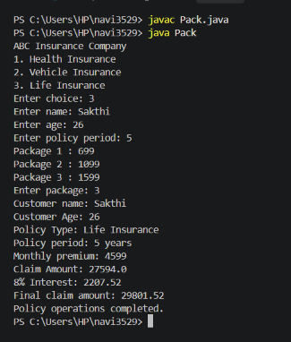

Program 2 :
Write a Java program to implement a Hospital Management System using packages. Create separate packages for Patient and Doctor. The Patient class should accept and display the patient's name and age, while the Doctor class should accept and display the doctor's name and specialization. Import these classes into the main class and display the patient and doctor details.
File 1: Patient.java
package hospital.patient;
import java.util.*;
public class Patient{
public String name;
public int age;
public void getdetails() {
Scanner s=new Scanner(System.in);
System.out.print("Enter patient name: ");
name=s.nextLine();
System.out.print("Enter patient age: ");
age=s.nextInt();
}
public void display(){
System.out.println("Patient Name: "+name);
System.out.println("Patient Age: "+age);
}
}
File 2: Doctor.java
package hospital.doctor;
import java.util.*;
public class Doctor{
public String name;
public String specialization;
public void getdetails(){
Scanner s=new Scanner(System.in);
System.out.print("Enter doctor name: ");
name=s.nextLine();
System.out.print("Enter specialization: ");
specialization=s.nextLine();
}
public void display() {
System.out.println("Doctor Name: "+name);
System.out.println("Specialization: "+specialization);
}
}
File 3: HospitalMain.java
import hospital.patient.Patient;
import hospital.doctor.Doctor;
public class HospitalMain{
public static void main(String args[]) {
Patient p=new Patient();
Doctor d=new Doctor();
System.out.println("HOSPITAL MANAGEMENT SYSTEM");
System.out.println();
p.getdetails();
System.out.println();
d.getdetails();
System.out.println();
System.out.println("PATIENT DETAILS");
p.display();
System.out.println();
System.out.println("DOCTOR DETAILS");
d.display();
}
}
Output
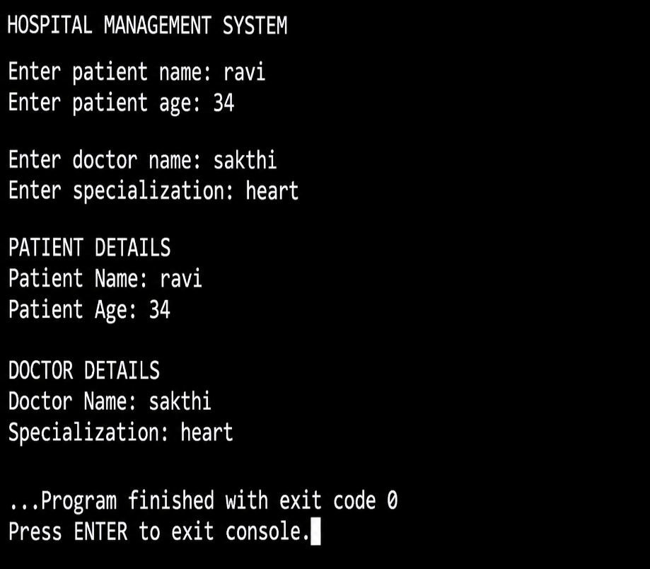
Result
Thus, the Java programs using packages and interfaces were successfully developed and executed. The concepts of user-defined packages, inter-package access, access specifiers, interfaces, and polymorphism were demonstrated successfully.

EXERCISE 11 – DATES AND STRINGS
AIM
To write Java programs using Strings and Date-Time classes to perform date, time, duration, billing, subscription, and attendance calculations.
PROCEDURE
- Import the required Java packages.
- Get the required input from the user.
- Read the date, time, and string values.
- Convert the input into date and time objects.
- Perform the required calculations.
- Display the result.
- Close the Scanner.
QUESTION 1 – HOTEL BILLING SYSTEM
Write a Java program to develop a hotel billing system. The program has to accept the customer's name, remove the trailing spaces, accept the check-in and check-out time, calculate the total duration of stay, number of days, number of nights, and generate the total bill.
Program
import java.util.Scanner;
import java.time.LocalDateTime;
import java.time.LocalDate;
import java.time.format.DateTimeFormatter;
public class HotelBilling{
public static void main(String[] args) {
Scanner sc=new Scanner(System.in);
System.out.print("Enter customer name: ");
String name=sc.nextLine();
name=name.stripTrailing();
DateTimeFormatter format=DateTimeFormatter.ofPattern("dd-MM-yyyy HH:mm");
System.out.print("Enter check-in time: ");
String in=sc.nextLine();
System.out.print("Enter check-out time: ");
String out=sc.nextLine();
LocalDateTime checkin=LocalDateTime.parse(in,format);
LocalDateTime checkout=LocalDateTime.parse(out,format);
LocalDate date=checkin.toLocalDate();
LocalDate endDate=checkout.toLocalDate();
int days=0;
while(date.isBefore(endDate)) {
date=date.plusDays(1);
days++;
}
int inMinutes=checkin.getHour()*60+checkin.getMinute();
int outMinutes=checkout.getHour()*60+checkout.getMinute();
int totalMinutes=days*24*60+outMinutes-inMinutes;
int hours=totalMinutes/60;
int minutes=totalMinutes%60;
int nights=days;
double rate=2000;
double bill=nights*rate;
System.out.println("--- Hotel Billing System ---");
System.out.println("Customer Name : "+name);
System.out.println("Check-in : "+checkin.format(format));
System.out.println("Check-out : "+checkout.format(format));
System.out.println("Duration : "+hours+" hours "+minutes+" minutes");
System.out.println("Number of days : "+days);
System.out.println("Number of nights : "+nights);
System.out.println("Room Rate : Rs."+rate);
System.out.println("Total Bill : Rs."+bill);
sc.close();
}
}
Output
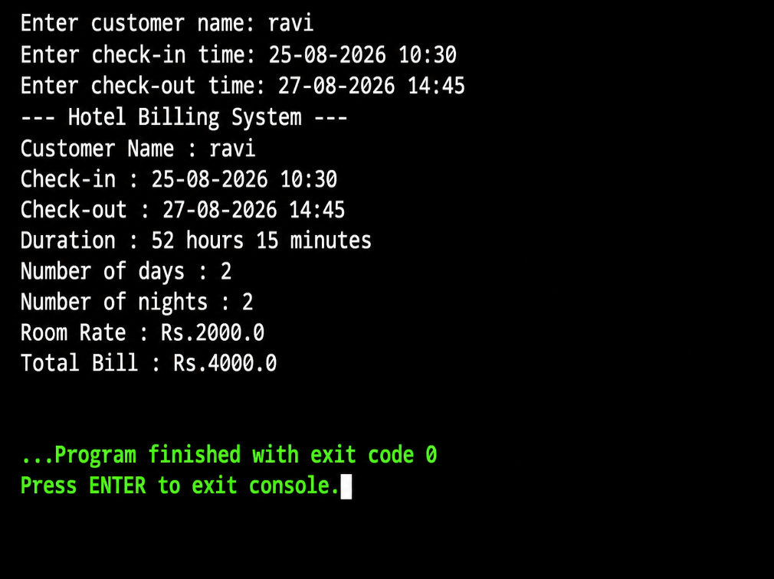
QUESTION 2 – SUBSCRIPTION RENEWAL
Write a Java program for a subscription renewal model in your application. The program should read the subscription start date and time, display the expiry date, day of expiry, and number of remaining days until expiry.
Program
import java.util.Scanner;
import java.time.LocalDateTime;
import java.time.LocalDate;
import java.time.format.DateTimeFormatter;
public class Renewal{
public static void main(String args[]) {
Scanner sc=new Scanner(System.in);
System.out.print("Enter subscription name: ");
String subscription=sc.nextLine();
System.out.print("Enter start date and time: ");
String input=sc.nextLine();
DateTimeFormatter format=DateTimeFormatter.ofPattern("dd-MM-yyyy HH:mm");
LocalDateTime start=LocalDateTime.parse(input,format);
int subscriptionDays=30;
LocalDateTime expiry=start.plusDays(subscriptionDays);
LocalDate expiryDate=expiry.toLocalDate();
String dayOfExpiry=expiryDate.getDayOfWeek().toString();
LocalDate today=LocalDate.now();
LocalDate date=today;
int remainingDays=0;
while(date.isBefore(expiryDate)) {
date=date.plusDays(1);
remainingDays++;
}
System.out.println("--- Subscription Details ---");
System.out.println("Subscription : "+subscription);
System.out.println("Start Date & Time : "+start.format(format));
System.out.println("Expiry Date : "+expiry.format(format));
System.out.println("Day of Expiry : "+dayOfExpiry);
System.out.println("Remaining Days : "+remainingDays);
sc.close();
}
}
Output
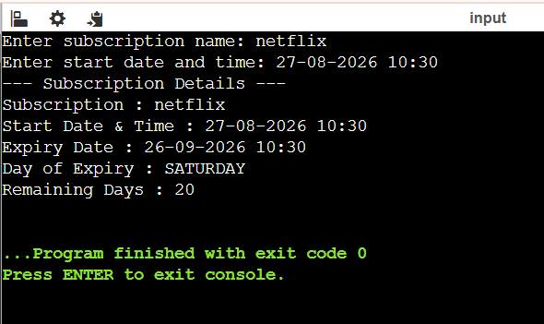
QUESTION 3 – SERVER JOB
A server started to process a job at 31/12/2025 11:59:45 PM. The job takes 30 seconds, 45 minutes, 26 hours and 3 days to complete. Determine the completion date and time. Calculate the total duration in hours. Display the day of the week when the job finished.
Program
import java.util.Scanner;
import java.time.LocalDateTime;
import java.time.DayOfWeek;
import java.time.format.DateTimeFormatter;
public class ServerJob{
public static void main(String args[]){
Scanner sc=new Scanner(System.in);
DateTimeFormatter format=DateTimeFormatter.ofPattern("dd/MM/yyyy hh:mm:ss a");
System.out.print("Enter start date and time: ");
String input=sc.nextLine();
LocalDateTime start=LocalDateTime.parse(input,format);
int seconds=30;
int minutes=45;
int hours=26;
int days=3;
LocalDateTime end = start.plusSeconds(seconds).plusMinutes(minutes). plusHours(hours).plusDays(days);
double totalHours=days*24+hours+(minutes/60.0)+(seconds/3600.0);
DayOfWeek day=end.getDayOfWeek();
System.out.println("--- SERVER JOB DETAILS ---");
System.out.println("Start Time : "+start.format(format));
System.out.println("Completion Time : "+end.format(format));
System.out.println("Total Duration : "+totalHours+" hours");
System.out.println("Day of Week : "+day);
sc.close();
}
}
Output

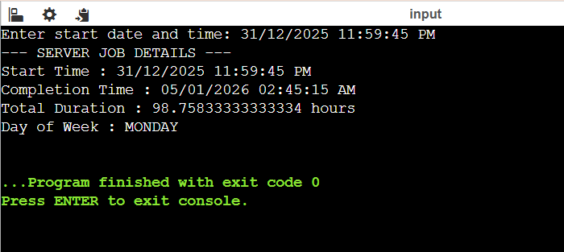
QUESTION 4 – EMPLOYEE ATTENDANCE
Write a Java program that accepts the employee's login time and logout time and checks whether the employee worked for 8 hours and whether the attendance is approved or not.
Program
import java.util.Scanner;
import java.time.LocalDateTime;
import java.time.format.DateTimeFormatter;
import java.time.Duration;
public class Employee{
public static void main(String[] args) {
Scanner sc=new Scanner(System.in);
DateTimeFormatter format=DateTimeFormatter.ofPattern("dd/MM/yyyy hh:mm:ss a");
System.out.print("Enter login time: ");
String loginInput=sc.nextLine();
System.out.print("Enter logout time: ");
String logoutInput=sc.nextLine();
LocalDateTime login=LocalDateTime.parse(loginInput,format);
LocalDateTime logout=LocalDateTime.parse(logoutInput,format);
long totalSeconds=Duration.between(login,logout).getSeconds();
long hours=totalSeconds/3600;
long minutes=(totalSeconds%3600)/60;
long seconds=totalSeconds%60;
boolean approved=totalSeconds>=8*60*60;
System.out.println("--- EMPLOYEE ATTENDANCE ---");
System.out.println("Login Time : "+login.format(format));
System.out.println("Logout Time : "+logout.format(format));
System.out.println("Work Duration : "+hours+" hours "+minutes+" minutes "+seconds+" seconds");
if(approved) {
System.out.println("Worked for 8 hours : YES");
System.out.println("Attendance Approved : YES");
}
else {
System.out.println("Worked for 8 hours : NO");
System.out.println("Attendance Approved : NO");
}
sc.close();
}
}
Output
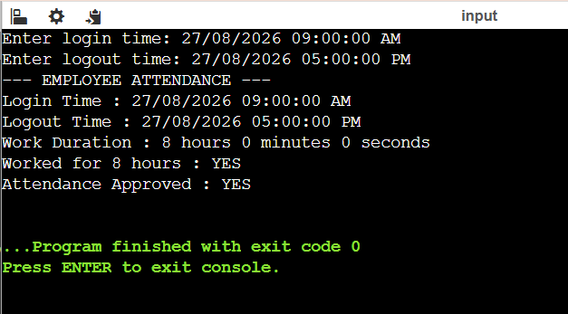
RESULT
Thus, the Java programs were successfully executed using Strings and Date-Time classes to perform date and time calculations, determine durations and expiry dates, calculate hotel billing, and verify employee attendance.

EXERCISE 12 : EXCEPTION HANDLING
Aim
To write a Java program to calculate the total amount of rainwater trapped between buildings using exception handling.
Procedure
- Get the array size from the user.
- Check whether the array size is negative.
- Read the building heights.
- Check whether the building heights are valid.
- Check whether the given index is within the array limit.
- Calculate the amount of rainwater trapped between the buildings.
- Handle possible exceptions using try-catch.
- Display the total amount of trapped rainwater.

Program :
A row of buildings is represented by an integer array containing their heights. Assume each building has a width of 1 unit and the distance between adjacent buildings is 0 unit. During rainfall, water may get trapped between the buildings.
Write a Java program to calculate the total amount of rainwater trapped and handle:
- Negative array size exception
- Input mismatch exception
- Invalid height exception
- Array index out of bounds exception
- User-defined exception for negative building height

import java.util.InputMismatchException;
import java.util.Scanner;
class InvalidHeightException extends Exception{
InvalidHeightException(String message){
super(message);
}
public String toString() {
return "Invalid Height Exception";
}
}

class NegativeArraySizeException extends Exception{
NegativeArraySizeException(String message) {
super(message);
}
public String toString() {
return "Negative Array Size Exception";
}
}

public class Demo{
static void size(int n) throws NegativeArraySizeException {
if (n < 0) {
throw new NegativeArraySizeException("Negative array size");
}
else {
System.out.println("Correct Array Size");
}
}
static void height(int a[], int n) throws InvalidHeightException {
for (int i = 0; i < n; i++) {
if (a[i] < 0) {
throw new InvalidHeightException("Height cannot be negative");
}
}
System.out.println("Entered heights are correct");
}
static void element(int a[], int n) throws InputMismatchException{
for (int i = 0; i < n; i++) {
if (a[i] < 0) {
throw new InputMismatchException("Invalid input");
}
}
System.out.println("Input elements are correct");
}
static void index(int i, int n) throws ArrayIndexOutOfBoundsException {
if (i < 0 || i >= n) {
throw new ArrayIndexOutOfBoundsException("Array index out of bounds");
}
else {
System.out.println("Index is within bound");
}
}
static void water(int a[], int n) {
int total = 0;
for (int i = 0; i < n; i++) {
int leftMax = a[i];
int rightMax = a[i];
for (int j = 0; j < i; j++) {
if (a[j] > leftMax) {
leftMax = a[j];
}
}
for (int j = i + 1; j < n; j++) {
if (a[j] > rightMax) {
rightMax = a[j];
}
}
int waterLevel = Math.min(leftMax, rightMax);
int trapped = waterLevel - a[i];
if (trapped > 0) {
total = total + trapped;
}
}
System.out.println("Total rainwater = " + total);
}

public static void main(String args[]){
Scanner sc = new Scanner(System.in);
try {
System.out.print("Enter the array size: ");
int n = sc.nextInt();

size(n);
int a[] = new int[n];
System.out.println("Enter the building heights:");
for (int i = 0; i < n; i++) {
a[i] = sc.nextInt();
}
element(a, n);
height(a, n);
System.out.print("Enter an index to check: ");
int i = sc.nextInt();
index(i, n);
water(a, n);
}
catch (NegativeArraySizeException e) {
System.out.println(e);
}
catch (InputMismatchException e) {
System.out.println("Input Mismatch Exception");
}
catch (InvalidHeightException e) {
System.out.println(e);
}
catch (ArrayIndexOutOfBoundsException e) {
System.out.println(e);
}
sc.close();
}
}

Output
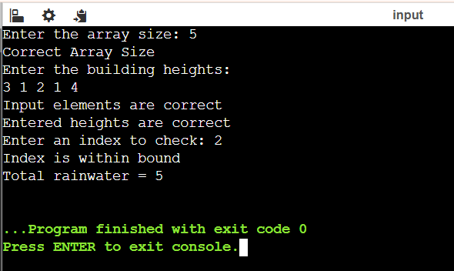
Result
Thus, the Java program was successfully executed to calculate the total amount of rainwater trapped between buildings and handle the required exceptions using try-catch.

